**Development of a data fusion model for detection of electronic components and generating of a life-cycle inventory PCB model**

BY

Bernhard Föllmer

Department of Machine Tools and Factory Management

Chair of Industrial Information Technology

Submitted in partial fulfillment of the requirements

for the degree of

Master of Science in

Physical Engineering Science

at the

Technical University of Berlin

13.10.2014

# Introduction

ewt

## Object recognition from 2D Images

Dg

## Recycling potential of electronic waste

Asd

# Recognition of electronic components

Erdt

## Data fusion model

Saf

## Image preprocessing

S

Asf

### Image rotation correction

To bypass the restriction of rotation invariant features for object recognition, the rotation angle of the printed circuit board images were determined. Since there is no fixed printed circuit board orientation, the orientation is set by invariants of 90 degree whereas most of the electronic parts are horizontal or vertical alligned. The whole process is based on the assumption that Conducter tracks and electronic parts are mostly horizontal or vertical aligned and there structure and borders producing more horizontal and vertical edges than edges with different orientations. The rotation angle estimation is based on the rotation property of a discrete Fourier transform. The DFT of an image rotated by and angle Θ is the DFT of the unrotated image, rotated by the same angle Θ. The rotation property of a DFT is derived in (Maria Petrou, Costas Petrou, 2010) and therefore omitted here. The image rotation correction process is shown in Figure 1.



Figure 1: Image rotation correction process

At first the Image is cropped to a squared image [2000 x 2000] to reduce the process runtime. The RGB image is converted to grayscaled image and canny edge detection is applied. Afterward a 2D DFT is computed from the edge image. To estimate the rotation angle, the amplitude of the shifted 2D FFT image is summed up over discretized angles and normalized by number of amplitudes per angle step. The discretization is done in steps of 0.25 degree from 0 to 360 degree which results in a discretization error of 0.125 degree. The maximum of the normalized sum of amplitudes over the angle corresponds to the image rotation angle. With this process the rotation angle can be estimated with invariants of 90 degree image rotation. An example of a rotated image by 3 degree, the edge image and amplitude of discrete Fourier transform is shown in Figure 2, Figure 3 and Figure 4. The accuracy of the angle estimation was not investigated in detail but inaccuracy could not be determined by eye.

|  |  |
| --- | --- |
|  |  |
|  |  |

|  |  |
| --- | --- |
| C:\Users\WIN\Masterthesis\Masterthesis\Masterarbeit_daten\2.2.1\rot1.png  Figure : Image rotated by 3.0 degree | C:\Users\WIN\Masterthesis\Masterthesis\Masterarbeit_daten\2.2.1\rot3.png  Figure : Canny edge image of the rotated image |
| C:\Users\WIN\Masterthesis\Masterthesis\Masterarbeit_daten\2.2.1\rot2.png  Figure : Shifted DFT of the rotated image (logarithmic representation) |  |



Figure : Summed amplitude over angle (invariants by 90 degree)

### Scaling determination based on scaling symbol

To bypass the restriction of scale invariant features for object recognition, the scaling of the printed circuit board images were determined using a scaling symbol.



Figure : Scale symbol

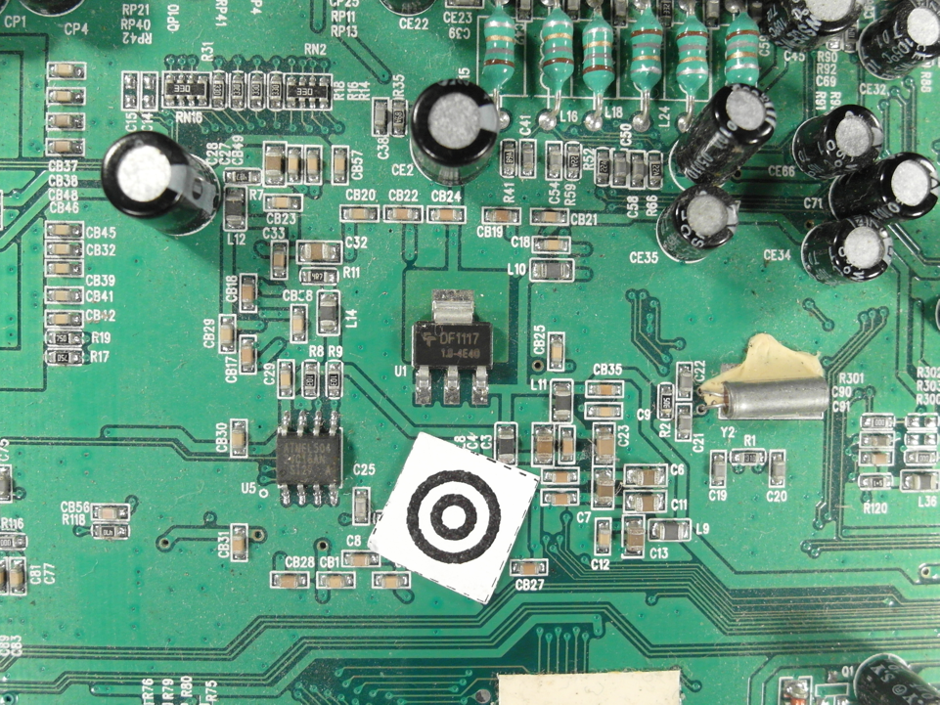

Figure : Scale symbol placed on the board

The scaling symbol is shown in Figure 1. The whole scaling determination process is shown in Figure 3.



Figure 8: Scaling determination process

At first the image is converted from the RGB color model to the HSV color model and the brightness channel (value channel) is used to make a discrete cosine transform. The discrete cosine transform is frequently used in image compression such as the JPEG format. The discrete cosine transform is similar to the discrete Fourier transform but uses only cosine functions as kernels. The discrete cosine transform is shown in Equation (1) and (2) (Rafael C.Gonzalez, 2008).

|  |  |
| --- | --- |
|  | () |
|  | () |

|  |  |
| --- | --- |
|  | () |

To suppress illumination changes, an ideal low pass filter is applied in the frequency domain in which the first 10 x 10 cosine coefficients were discarded. Afterwards the inverse cosine transform is applied to get the image in time-domain. To extract the two dark circles of the scaling symbol, Otsu’s method is used to automatically perform thresholding. To avoid salt and pepper noise, a morphological closing operator (5x5) is applied. The image is inverted and the eccentricity and bounding boxes are determined of the blobs. All blobs inside the eccentricity interval and inside the diameter interval are maintained, all others are discarded.

|  |  |
| --- | --- |
| } | () |

To find the center of the scaling symbol, the distances between the centers of all blobs are calculated and the two blobs with the smallest distance are the inner and outer dark rings of the scaling symbol. The outer diameter of the larger blob is used as reference to calculate the image scale.

|  |  |
| --- | --- |
|  | () |

|  |  |
| --- | --- |
| C:\Users\WIN\Masterthesis\Masterthesis\Masterarbeit_daten\2.2.2\scale5.png  Figure : Value channel (brightness) of HSV color image | Figure : Cosine transform filtered image |
| Figure : Otsu thresholding | C:\Users\WIN\Masterthesis\Masterthesis\Masterarbeit_daten\2.2.2\scale6.png  Figure : Blobs of the scaling symbol |

## Electronic component detection

Asdsad

### Electronic component detection based on color based background detection

Sdf

### Electronic component detection based on 3D range image

Sd

### Electronic component detection based on normalized correlation

Sasd

## Feature extraction algorithms for electronic components

Sad

### Fourier analyses for feature extraction

Asd

### Histogram based feature extraction

Sad

### Segment based feature extraction

Asd

### PCA based feature extraction in Laplacian of Gaussian filtered gray scaled image

Asfd

## Feature selection and feature fusion techniques for classification

Asd

# Classification

Asdf

## Random forest classifier

asd

## Support vector machine classifier

Asdf

# Decision fusion for component recognition

Asf

# Optical character recognition of electronic component marking

Dsf

## Introduction

Dsf

## Character segmentation

Dsf

## Optical character recognition with Tesseract and Cognex Vision Pro software

Asdf

## Electronic part label verification based on Octopart database

Dsf

# Experimental results

Asfd

## Dataset creation

The dataset consist of 12 electronic components which were analyzed. The components are listed in Appendix A.

A section of the database is shown in



Figure : Database section

### Image acquisition

Asf

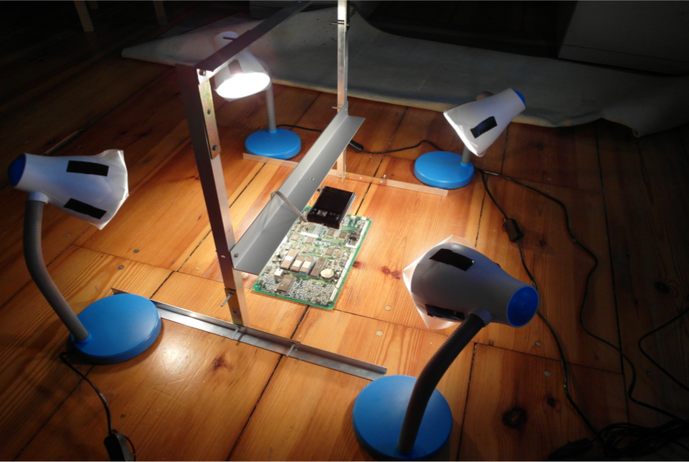

Figure : Image aquistion system

## Classification results

Ef

## Optical character recognition results

Asd

# Life-cycle inventory analyses of printed circuit boards

Asdf

## Introduction

Safd

## Printed circuit board region classification based on electronic part recognition results

Sad

## GaBi-Software and LCI data availability of electronic components

Saf

## ILCD format for LCA-data exchange

# Conclusion and prospects

Dg

# Appendix A

Table 1: Components in database

|  |  |
| --- | --- |
| **Component name and description** | **Component image** |
|  | C:\Users\WIN\Masterthesis\Masterthesis\Masterarbeit_daten\6.1\Bib1.png |
|  | C:\Users\WIN\Dropbox\Masterthesis\6.1\Bib2.png |
|  | C:\Users\WIN\Dropbox\Masterthesis\6.1\Bib5.png |
|  | C:\Users\WIN\Dropbox\Masterthesis\6.1\Bib6.png |
|  | C:\Users\WIN\Dropbox\Masterthesis\6.1\Bib7.png |
|  | C:\Users\WIN\Dropbox\Masterthesis\6.1\Bib8.png |
|  | C:\Users\WIN\Dropbox\Masterthesis\6.1\Bib9.png |
|  | C:\Users\WIN\Dropbox\Masterthesis\6.1\Bib11.png |
|  | C:\Users\WIN\Dropbox\Masterthesis\6.1\Bib14.png |
|  | C:\Users\WIN\Dropbox\Masterthesis\6.1\C1.png |
|  | C:\Users\WIN\Dropbox\Masterthesis\6.1\T1.png |